



A
Project Report on
AI Workplace Productivity
Submitted in partial fulfillment of completion of the course
AI Micro Degree
Year 2026

Submitted by:
Kashish Gautam
Under Guidance of:
Deepika Singh (Edunet)

Abstract
Acknowledgement
Table of Contents
- Introduction to Problem
- Literature Review
- Proposed Solution
- Requirements
4.1 Technology Stack
4.2 Hardware
4.3 Software
4.4 Deployment Environment
5. User Requirements
6. Design Documentation
7. Implementation Details
8. Testing
9. Deployment
10. Future Scope
11. Conclusion
Appendix A Project Code
Appendix B Screenshot of Project
Appendix C abbreviation
References

Abstract

The AI Workplace Productivity Dashboard is a data analytics project designed to evaluate employee performance, automation levels, burnout risk, and work-life balance using interactive visualizations. The system leverages Power BI for data transformation, modelling, and dashboard creation.
The primary objective of this project is to provide organizations with actionable insights to enhance productivity and optimize workforce management. By comparing manual work hours with AI-driven automation and analysing burnout indicators, the dashboard enables data-driven decision-making.
The results demonstrate that integrating AI tools in workplace environments significantly improves operational efficiency while maintaining employee well-being.

Acknowledgement
I would like to express my sincere gratitude to my faculty mentor and institution for providing guidance and support throughout the completion of this project. I also extend my appreciation to the developers of Power BI and related tools that made this analytical implementation possible. Their continuous innovation in data analytics technologies has significantly contributed to the successful execution of this project.
• Data Collection and Cleaning – Dataset preparation and pre-processing
• Data Modelling – Creating relationships and DAX measures
• Dashboard Design – Visual layout, KPI development, and interactive filters
• Documentation – Report writing and project structuring

Dataset Description
Explain:
- Total Employees: 4500
- Focus Hours data
- Automation records
- Burnout level
- Experience (1–20 years)
- Deadline pressure

Data Cleaning Process
Write steps:
- Imported dataset into Power BI
- Checked missing values
- Removed duplicates
- Renamed columns
- Created calculated columns
- Applied data types

Data Modelling
Explain:
- Relationships created
- Measures created using DAX
- KPI calculations
Example measures:
- Total Employees
- Total Focus HoursTotal Tasks Automated

Introduction to Problem

Organizations often face challenges in measuring employee productivity effectively. Traditional performance evaluation systems primarily focus on output metrics while ignoring automation impact, burnout risk, and work-life balance. With increasing adoption of AI technologies, there is a need for an integrated analytical system that evaluates both productivity and employee well-being. This project addresses these gaps by developing a comprehensive AI-based productivity monitoring dashboard.

Literature Review

Recent studies highlight that AI-driven automation enhances operational efficiency and reduces manual workload. Research also indicates that employee burnout significantly impacts productivity and organizational performance. Data visualization tools such as Power BI have proven effective in transforming complex datasets into meaningful insights. The integration of automation metrics with human productivity indicators provides a holistic approach to workforce analytics.

3. Proposed Solution
The proposed solution is an interactive AI Workplace Productivity Dashboard developed using Power BI. The dashboard integrates employee data, automation metrics, burnout levels, and work-life balance indicators. It provides real-time visualization of KPIs, enabling management to monitor productivity trends and identify performance gaps efficiently.

4. Requirements

4.1 Technology Stack
- Power BI Desktop
- Power Query
- DAX (Data Analysis Expressions)
- Microsoft Excel

4.2 Hardware Requirements
- Minimum 4GB RAM (8GB recommended)
- Intel i3 or higher processor
- Windows 10/11 operating system

4.3 Software Requirements
- Microsoft Power BI Desktop
- Microsoft Office Suite
- Web Browser (for documentation and research)

4.4 Deployment Environment
The dashboard can be deployed on Power BI Service for cloud-based sharing and organizational access.

5. User Requirements
- Ability to monitor employee productivity
- Compare manual and AI-based work hours
- Analyses burnout risk and work-life balance
- Filter results by job role, experience, and deadline pressure
- Access interactive KPI metrics

6. Design Documentation
The dashboard is structured into three primary sections:
- KPI Section – Displays total employees, focus hours, tasks automated, and productivity score.
- Analytical Charts – Includes automation comparison, burnout analysis, and collaboration distribution.
- Interactive Filters – Job role, experience level, and deadline pressure slicers.
The interface follows a professional layout with consistent color themes and structured visualization alignment.

7. Implementation Details
The dataset was imported into Power BI and cleaned using Power Query. Missing values were handled, and appropriate data types were assigned. Relationships between tables were created in the data model. DAX measures were developed to calculate KPIs such as total employees, focus hours, and automated tasks. Various charts and slicers were implemented to enhance interactivity and analytical depth.

8. Testing
Functional testing was performed to ensure accurate KPI calculations and filter responsiveness. Data validation checks were conducted to confirm consistency between raw data and visual outputs. Performance testing ensured smooth dashboard interaction without lag.

9. Deployment
The dashboard can be published to Power BI Service for cloud-based access. It allows secure sharing with stakeholders and supports scheduled data refresh for updated analysis.

10. Future Scope
Future enhancements may include real-time HR system integration, AI-based predictive analytics for burnout forecasting, automated performance recommendations, and mobile application deployment for remote monitoring.

11. Conclusion
The AI Workplace Productivity Dashboard successfully integrates automation metrics with employee performance indicators to provide comprehensive productivity analysis. The project demonstrates how AI and data visualization can enhance organizational efficiency while supporting employee well-being. The system enables informed decision-making and promotes sustainable workplace growth.

Appendix A – Project Code (DAX Measures)
Below are the DAX measures used in the AI Workplace Productivity Dashboard for KPI calculations and analytical visualizations.

1. Total Employees
Total Employees = DISTINCTCOUNT('Employee Data'[Employee ID])
Description:
Calculates the total number of unique employees in the dataset.

2. Total Focus Hours
Total Focus Hours = SUM('EmployeeData'[focus_hours_per_week])
Description:
Calculates the total weekly focus hours of all employees.

3. Total Tasks Automated
Total Tasks Automated = SUM('EmployeeData'[tasks_automated])
Description:
Calculates the total number of tasks automated using AI tools.

4. Total Manual Work Hours
Total Manual Work Hours = SUM('EmployeeData'[manual_work_hours_per_week])
Description:
Computes the total manual work hours performed by employees.

5. Total Meeting Hours
Total Meeting Hours = SUM('EmployeeData'[meeting_hours_per_week])
Description:
Calculates the total time spent in meetings per week.

6. Productivity Score
Productivity Score =
DIVIDE(
[Total Focus Hours] + [Total Tasks Automated],
[Total Manual Work Hours] + [Total Meeting Hours],
0
)
Description:
Measures overall productivity by comparing productive hours and automated tasks against manual and meeting hours.

7. Average Work-Life Balance Score
Average Work Life Balance =
AVERAGE('EmployeeData'[work_life_balance_score])
Description:
Calculates the average work-life balance rating across employees.

8. Burnout Level Count
Burnout Count =
COUNT('EmployeeData'[burnout_risk_level])
Description:
Counts the number of burnout risk entries in the dataset.

9. Automation Percentage
Automation Percentage =
DIVIDE(
[Total Tasks Automated],
[Total Tasks Automated] + [Total Manual Work Hours],
0
) * 100
Description:
Calculates the percentage of work completed through automation.

Appendix B – Screenshot of Project
Includes complete dashboard screenshots and visual explanations.
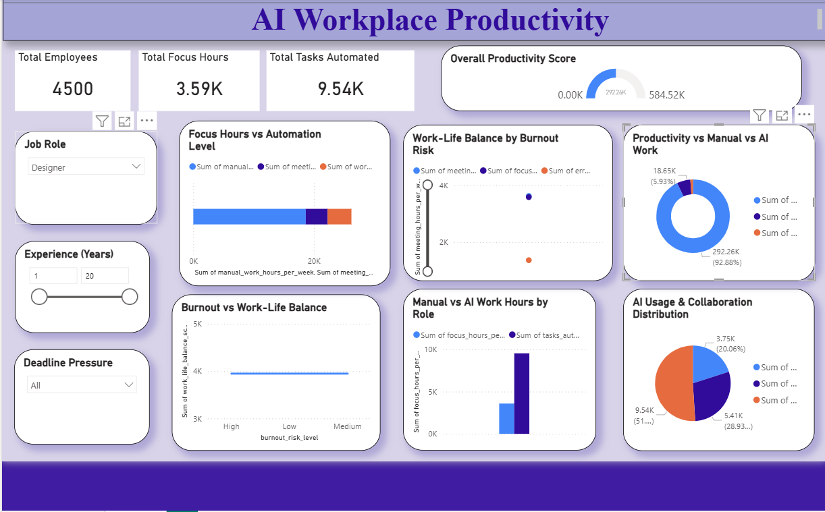

Appendix C – Abbreviations
AI – Artificial Intelligence
KPI – Key Performance Indicator
DAX – Data Analysis Expressions
HR – Human Resources

References
- Microsoft Power BI Documentation
- Research Articles on AI in Workplace Productivity
- Data Visualization Best Practices Literature

